- Create a GitHub account.
Created the account successfully in previous day task during bash scripting.
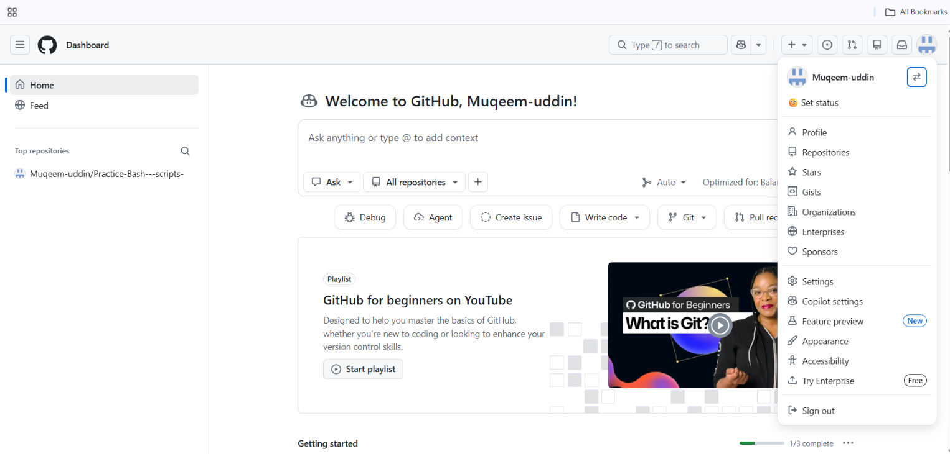

- Set up MFA (Multi-Factor Authentication) for the GitHub account using a mobile app.
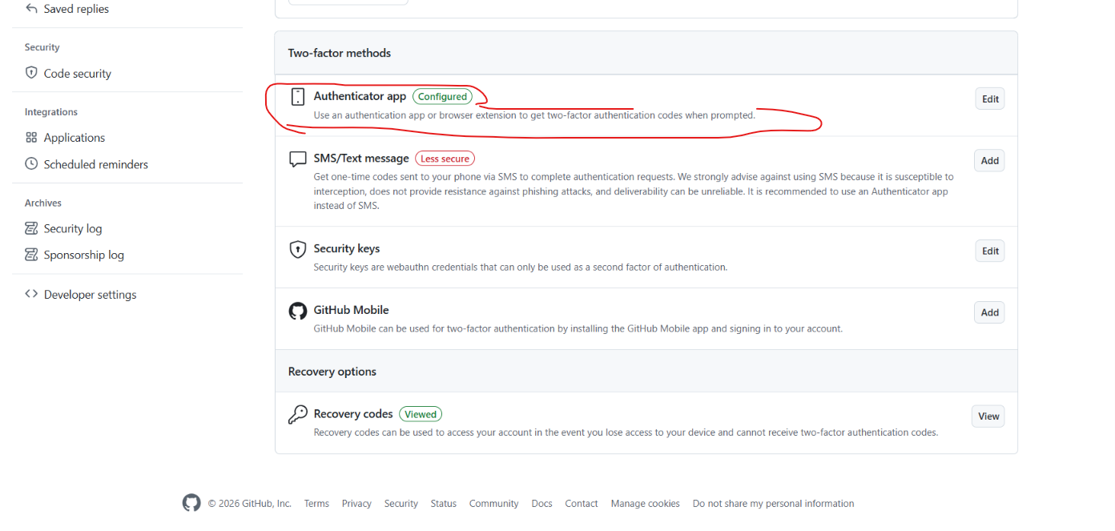

- Execute all commands shown in the video.
Push the data successfully as we can see the commit file in 2 screenshot.
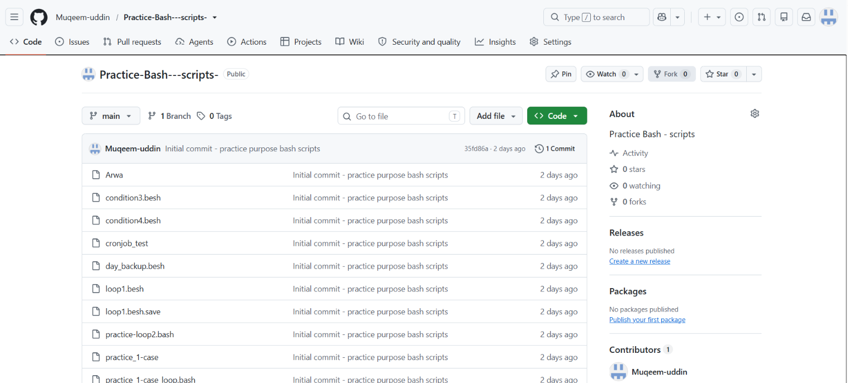
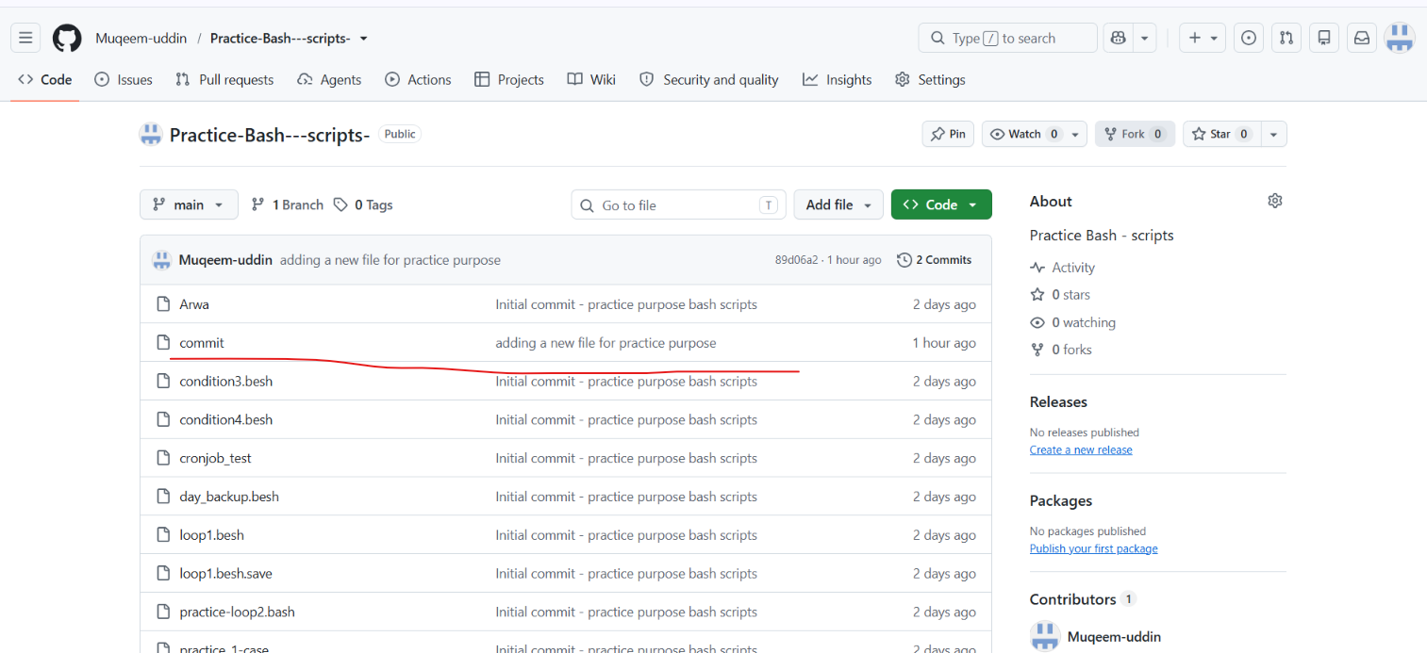
Execute some basic commands to add the file and reset the file

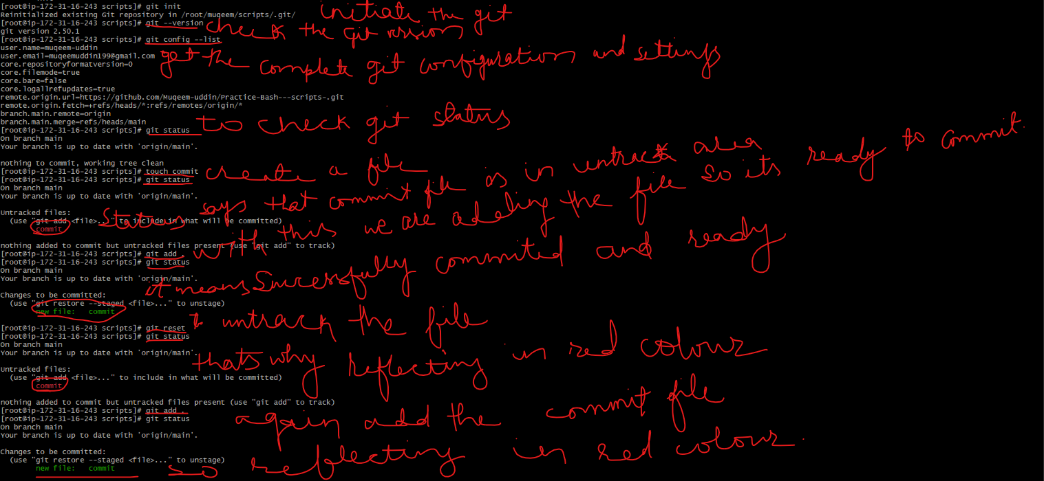
Committing and checking commits and commit Ids, create sshkeygenand check the password of keygen and copied and [paste in the github & it was connected with the HTTPS so disconnected with the https and connected with ssh to passwordless login because we
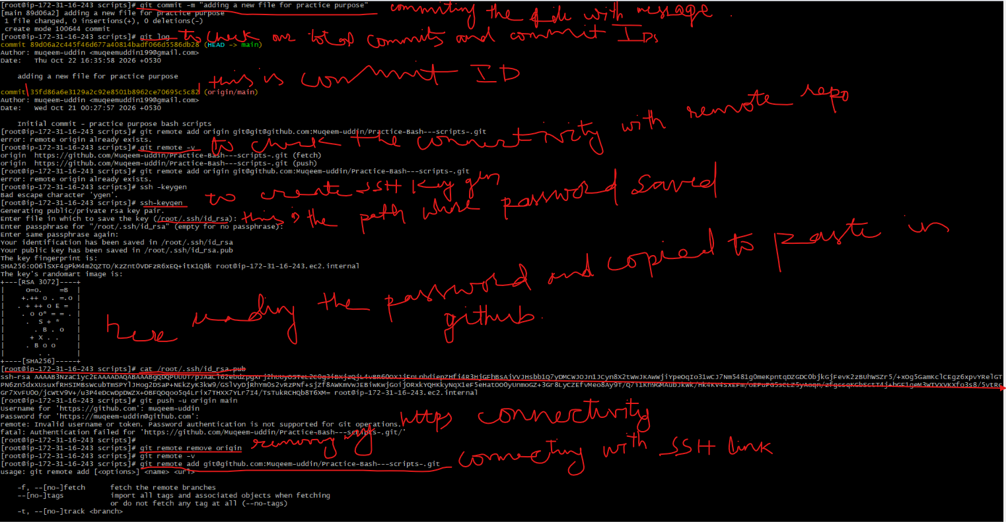
Adding the github SSH link to the GIT and pushing the file with the SSH link


